Udemy Course Note
Section: 7 - Scala
- Conditional Statement
- Loops
- Functions
- Class
- Constructor
- Inheritance (all type of Inheritance like Singal, Multiple, Hybrid etc.)
- Method overriding and method Overwriting
- Case class
- Higher order functions and Lambada Expressions
- Option Type
- Exception handling
- Scala collections
- Collection methods
- Variable Arguments
- Working with the file
Section: 8 – Introduction of Spark
- What is Spark
- Why is spark faster than MapReduce
RDD : Operation of RDD
- Transformation
Transformation is the function it will be change the data, apply filter condition, Ex.
Narrow Transformation : map, filter, union
Wide Transformation : distinct(), groupByKey(), reduceByKey(), sortByKey(), join(other)
- Action
Actions it the function it doesn’t change data Ex, count(), collect(), reduce()
Spark follows lazy evaluation, that’s why it’s fast compare to MapReduce
Section: 9 – Spark RDDs
- Read and write files
- Deploying code to Cluster : Created Jar file using maven build and run into the cluster
- What is RDD
Section: 10 – Spark DataFrames (Mosely use in real project)
DataFrame : Operation – Action and Transformation
- Transformation
Transformation is the function it will be change the data, Ex.
Narrow Transformation: select(),filter() or where(), withColumn(), drop(), alias()
Wide Transformation: groupBy(), distinct(), orderBy() or sort(), join(), union()
- Action
Actions the function it doesn’t change data Ex, show(), collect(), count(), first() / head(), take(n), write, foreach()
- What is Data Frame: Data Frame are distributed collection of data organized into name columns, it is similar like SQL tables, we can Create Data Frame using RDD like first create RDD and convert into Data frame and another way to create data frame Seamlessly DataFrame.
Process the data frame by (1) Creating temp view (2) Using the DSL
- Creating Data Frame from RDD:
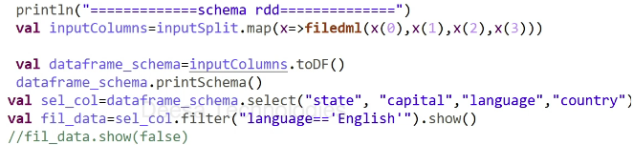
Using schema RDD (DSL): Eg: rdd1.toDF() Generally use DSL

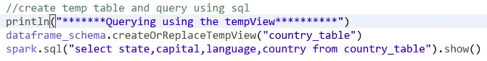
sel_col.show(false) : -> it will show full text in the column; data will be not trinketed

Using row RDD: val df = spark.createDataFrame(rowrdd, structschema)
- Create Spark Seamless DataFrame – Reading and writing (Most commonly use)
For reading: spark.read.format().option().load()
For writing: df.write.format().option().save()
- Reading and writing AVRO Data
- Reading and writing XML Data
- Reading Multi line Json
- Write mode in spark: Error, Append, Ignore, Overwrite
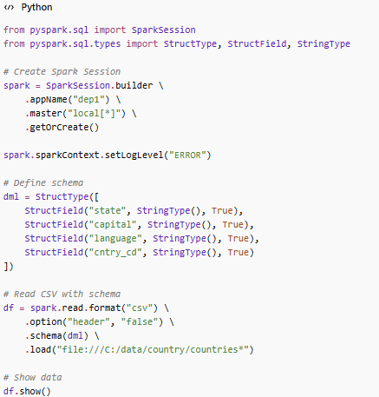
- Passing Schema to a file (python)

Partition data:

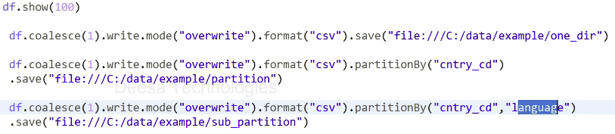
Transformation and filter:

Section: 11 – Spark Advance
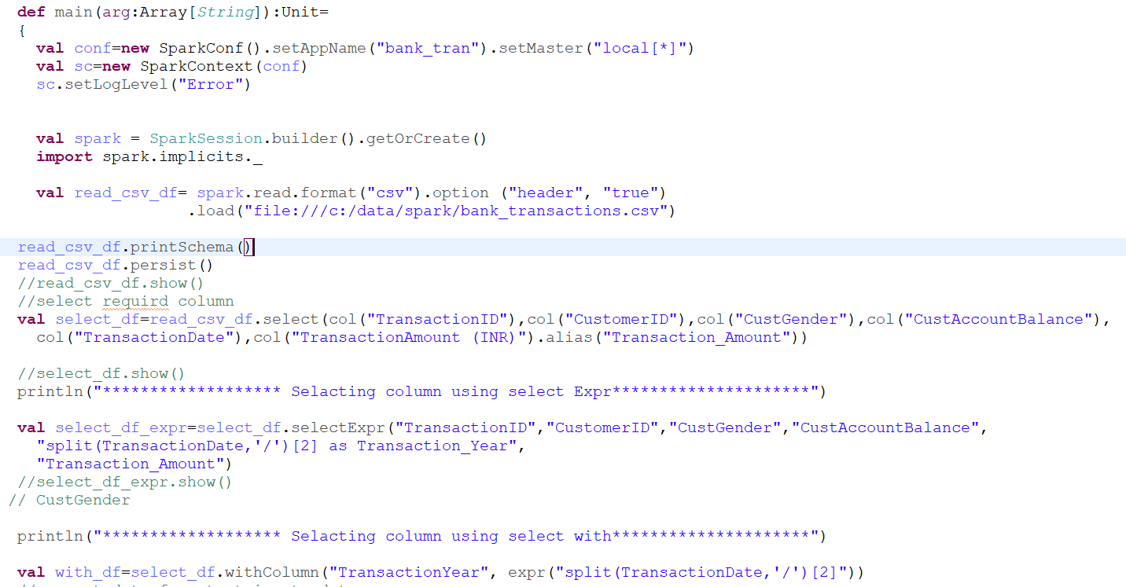
- More Transformation

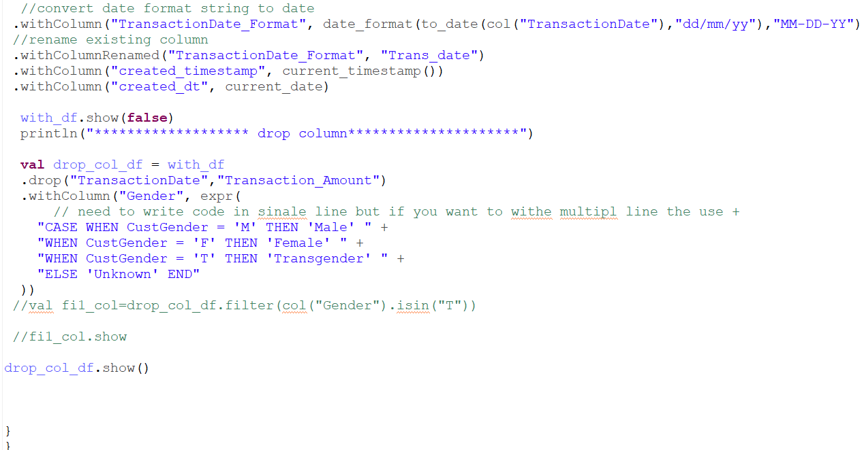

- Revolve duplicate
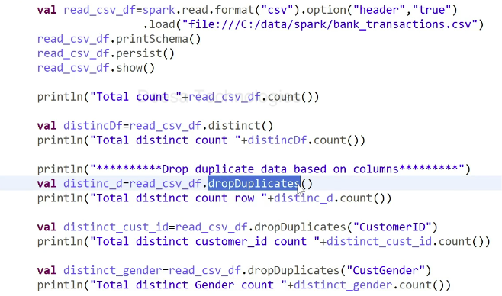
distinct_gender.show()
}
}

- Shorting the data
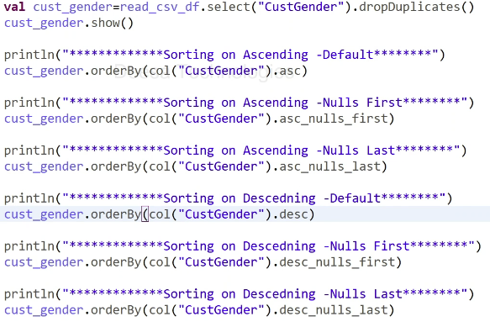
- Handling Null
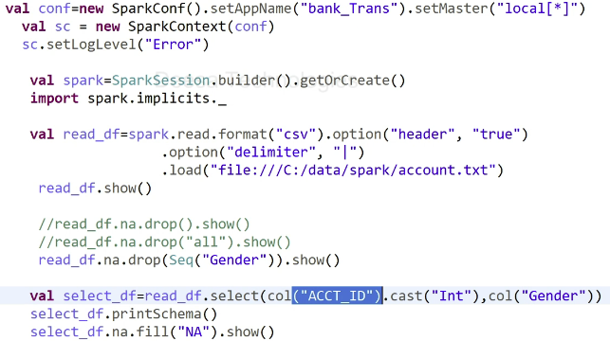
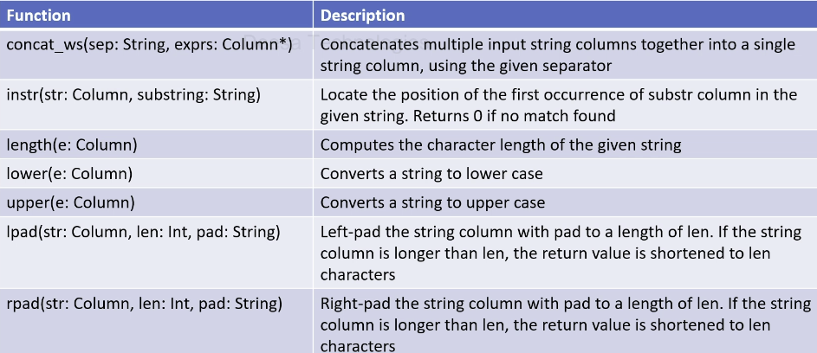
- Working with string functions

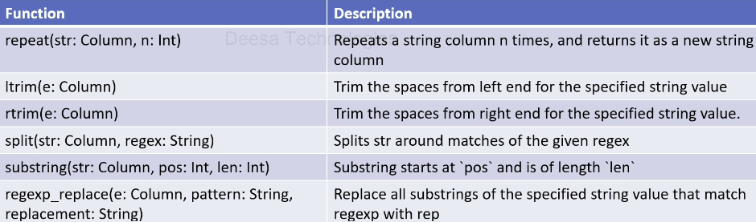

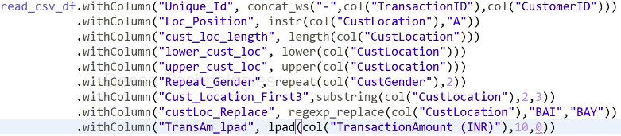

Note : (INR)”),10,”0”))
.show()
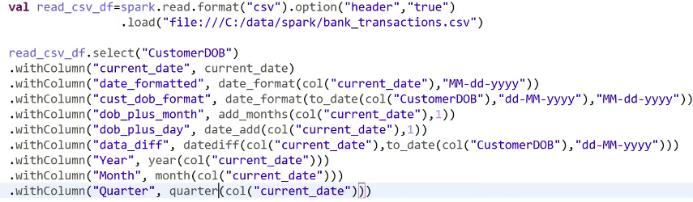
- Working with the date

.show()
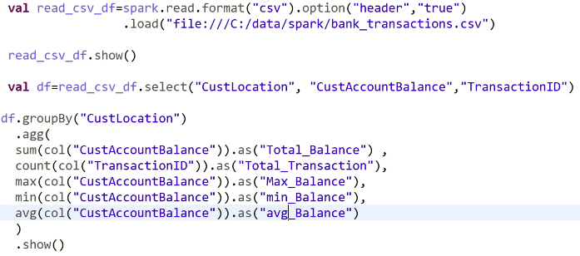
- Applying Aggregation

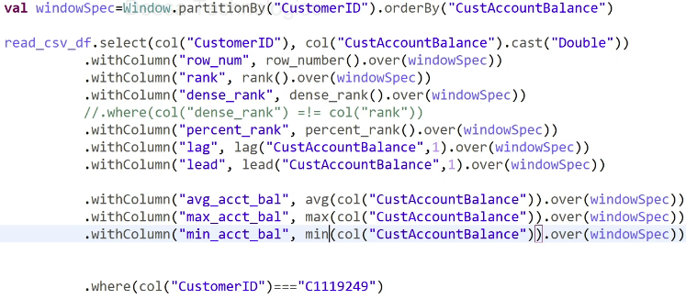
- Windows functions

.show()
- Pivoting in Spark
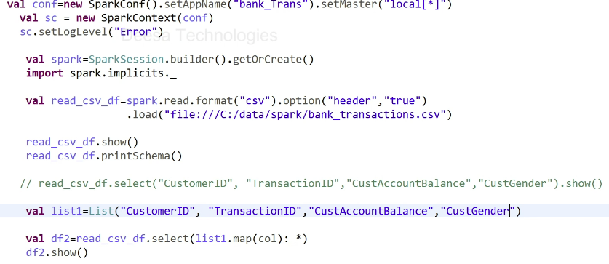
- Passing list of Columns to Dataframe

- Join in Spark
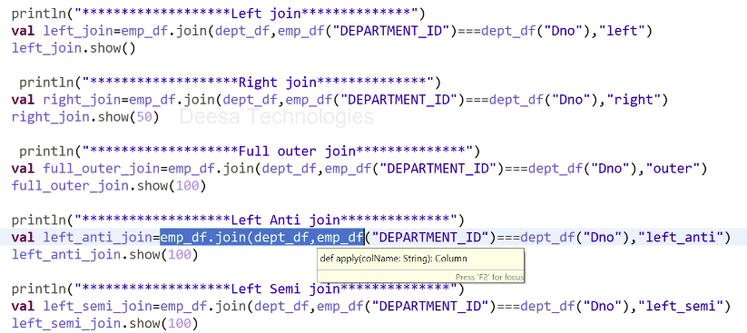
Section: 12 – Productionalizing Code
- How does your code run in Production
- Deploy code in Prod – Parameterizing the File name
- Parameterizing using Config file
Here is the code for configFile1.scala
- package sparkPractise

- import com.typesafe.config.{Config,ConfigFactory}

- object configFile1 {
- def main(arg:Array[String]):Unit=
- {
- ConfigFactory.invalidateCaches()
- println("**************Application.conf**********")

- val config=ConfigFactory.load("Application.conf").getConfig("MyProject")
- println(config.getString("spark.app-name"))
- println(config.getString("spark.master"))

- println(config.getString("mysql.username"))
- println(config.getString("mysql.password"))

- println("**************Application.properties**********")
- val config1=ConfigFactory.load("Application.properties")
- println(config1.getString("dev.input.base.dir"))
- println(config1.getString("dev.output.base.dir"))

- println(config1.getString("prod.input.base.dir"))
- println(config1.getString("prod.output.base.dir"))

- println(config1.getString("input"))
- println(config1.getString("output"))

- }
- }

Here is the code for configFile2.scala:
- package sparkPractise

- import org.apache.spark.SparkConf
- import org.apache.spark.sql.SparkSession
- import org.apache.spark.SparkContext
- import com.typesafe.config.{Config,ConfigFactory}

- object configFile2 {

- def main(arg:Array[String]):Unit=
- {
- val conf=new SparkConf().setAppName("job1").setMaster("local[*]")
- val sc=new SparkContext(conf)
- sc.setLogLevel("Error")

- val spark=SparkSession.builder().config(conf).getOrCreate()

- ConfigFactory.invalidateCaches()
- val config=ConfigFactory.load("Application.properties")

- //dev
- if(arg(0)=="dev")
- {
- val read_csv_df=spark.read.format("csv").option("header","true")
- .load(config.getString("dev.input.base.dir"))

- read_csv_df.write.format("csv").option("header","true")
- .mode("overwrite")
- .save(config.getString("dev.output.base.dir"))
- }

- //prod
- if(arg(0)=="prod")
- {
- val read_csv_df=spark.read.format("csv").option("header","true")
- .load(config.getString("prod.input.base.dir"))

- read_csv_df.write.format("csv").option("header","true")
- .mode("overwrite")
- .save(config.getString("prod.output.base.dir"))

- }

- }

- }

*********************** spark code - useful *********************************

DATA READING
Data Reading JSON

df_json = spark.read.format('json').option('inferSchema',True)\
.option('header',True)\
.option('multiLine',False)\
.load('/FileStore/tables/drivers.json')

df_json.display()

Data Reading Utils

dbutils.fs.ls('/FileStore/tables/')

df=spark.read.format('csv').option('inferSchema',True).option('header',True).load('/FileStore/tables/BigMart_Sales.csv')

df.display()

Schema Definition

df.printSchema()

DDL SCHEMA

my_ddl_schema = '''
Item_Identifier STRING,
Item_Weight STRING,
Item_Fat_Content STRING,
Item_Visibility DOUBLE,
Item_Type STRING,
Item_MRP DOUBLE,
Outlet_Identifier STRING,
Outlet_Establishment_Year INT,
Outlet_Size STRING,
Outlet_Location_Type STRING,
Outlet_Type STRING,
Item_Outlet_Sales DOUBLE

'''

df = spark.read.format('csv')\
.schema(my_ddl_schema)\
.option('header',True)\
.load('/FileStore/tables/BigMart_Sales.csv')

df.display()

df.printSchema()

StructType() Schema

from pyspark.sql.types import *
from pyspark.sql.functions import *

my_strct_schema = StructType([ StructField('Item_Identifier',StringType(),True), StructField('Item_Weight',StringType(),True), StructField('Item_Fat_Content',StringType(),True), StructField('Item_Visibility',StringType(),True), StructField('Item_MRP',StringType(),True), StructField('Outlet_Identifier',StringType(),True), StructField('Outlet_Establishment_Year',StringType(),True), StructField('Outlet_Size',StringType(),True), StructField('Outlet_Location_Type',StringType(),True), StructField('Outlet_Type',StringType(),True), StructField('Item_Outlet_Sales',StringType(),True)
])
df = spark.read.format('csv')
.schema(my_strct_schema)
.option('header',True)
.load('/FileStore/tables/BigMart_Sales.csv')

df.printSchema()

TRANSFORMATIONS
SELECT

df.display()

df.select(col('Item_Identifier'),col('Item_Weight'),col('Item_Fat_Content')).display()

ALIAS

df.select(col('Item_Identifier').alias('Item_ID')).display()

df.display()

FILTER
Scenario - 1

df.filter(col('Item_Fat_Content')=='Regular').display()

Scenario - 2

df.filter((col('Item_Type') == 'Soft Drinks') & (col('Item_Weight')<10)).display()

Scenario - 3

df.filter((col('Outlet_Size').isNull()) & (col('Outlet_Location_Type').isin('Tier 1','Tier 2'))).display()

withColumnRenamed

df.withColumnRenamed('Item_Weight','Item_Wt').display()

withColumn
Scenario - 1

df = df.withColumn('flag',lit("new"))

df.display()

df.withColumn('multiply',col('Item_Weight')*col('Item_MRP')).display()

Scenario - 2

df = df.withColumn('Item_Fat_Content',regexp_replace(col('Item_Fat_Content'),"Regular","Reg"))\
.withColumn('Item_Fat_Content',regexp_replace(col('Item_Fat_Content'),"Low Fat","Lf"))

df.display()

Type Casting

df = df.withColumn('Item_Weight', col('Item_Weight').cast(StringType()))

df.printSchema()

sort
Scenario - 1

df.sort(col('Item_Weight').desc()).display()

Scenario - 2

df.sort(col('Item_Visibility').asc()).display()

Scenario - 3

df.sort(['Item_Weight','Item_Visibility'],ascending = [0,0]).display()

Scenario - 4

df.sort(['Item_weight','Item_Visibility'], ascending = [0,1]).display()

Limit

df.limit(10).display()

DROP
Scenario-1

df.drop('Item_Visibility').display()

Scenario-2

df.drop('Item_Visibility','Item_Type').display()

DRop_Duplicates

df.dropDuplicates().display()

Scenario - 2

df.drop_duplicates(subset=['Item_Type']).display()

df.distinct().display()

UNION and UNION BY NAME
Preaparing Dataframes

data1 = [('1','kad'),
('2','sid')]
schema1 = 'id STRING, name STRING'

df1 = spark.createDataFrame(data1,schema1)

data2 = [('3','rahul'),
('4','jas')]
schema2 = 'id STRING, name STRING'

df2 = spark.createDataFrame(data2,schema2)

df1.display()

df2.display()

Union

df1.union(df2).display()

data1 = [('kad','1',),
('sid','2',)]
schema1 = 'name STRING, id STRING'

df1 = spark.createDataFrame(data1,schema1)

df1.display()

df1.union(df2).display()

Union by Name

df1.unionByName(df2).display()

String Functions
Initcap()

df.select(upper('Item_Type').alias('upper_Item_Type')).display()

Date Functions
Current_Date

df = df.withColumn('curr_date',current_date())

df.display()

Date_Add()

df = df.withColumn('week_after',date_add('curr_date',7))

df.display()

Date_Sub()

df.withColumn('week_before',date_sub('curr_date',7)).display()

df = df.withColumn('week_before',date_add('curr_date',-7))

df.display()

DateDIFF

df = df.withColumn('datediff',datediff('week_after','curr_date'))

df.display()

Date_Format()

df = df.withColumn('week_before',date_format('week_before','dd-MM-yyyy'))

df.display()

Handling Nulls
Dropping NUlls

df.dropna('all').display()

df.dropna('any').display()

df.dropna(subset=['Outlet_Size']).display()

df.display()

Filling Nulls

df.fillna('NotAvailable').display()

df.fillna('NotAvailable',subset=['Outlet_Size']).display()

SPLIT and Indexing
SPLIT

df.withColumn('Outlet_Type',split('Outlet_Type',' ')).display()

Indexing

df.withColumn('Outlet_Type',split('Outlet_Type',' ')[1]).display()

Explode

df_exp = df.withColumn('Outlet_Type',split('Outlet_Type',' '))

df_exp.display()

df_exp.withColumn('Outlet_Type',explode('Outlet_Type')).display()
df_exp.display()
df_exp.withColumn('Type1_flag',array_contains('Outlet_Type','Type1')).display()

GroupBY
Scenario - 1
df.display()
df.groupBy('Item_Type').agg(sum('Item_MRP')).display()

Scenario - 2
df.groupBy('Item_Type').agg(avg('Item_MRP')).display()
SCenario - 3
df.groupBy('Item_Type','Outlet_Size').agg(sum('Item_MRP').alias('Total_MRP')).display()
Scenario - 4
df.groupBy('Item_Type','Outlet_Size').agg(sum('Item_MRP'),avg('Item_MRP')).display()

Collect_List

data = [('user1','book1'),
('user1','book2'),
('user2','book2'),
('user2','book4'),
('user3','book1')]

schema = 'user string, book string'

df_book = spark.createDataFrame(data,schema)

df_book.display()

df_book.groupBy('user').agg(collect_list('book')).display()

df.select('Item_Type','Outlet_Size','Item_MRP').display()

PIVOT

df.groupBy('Item_Type').pivot('Outlet_Size').agg(avg('Item_MRP')).display()

When-Otherwise
Scenario - 1

df = df.withColumn('veg_flag',when(col('Item_Type')=='Meat','Non-Veg').otherwise('Veg'))

df.display()

df.withColumn('veg_exp_flag',when(((col('veg_flag')=='Veg') & (col('Item_MRP')<100)),'Veg_Inexpensive')\
.when((col('veg_flag')=='Veg') & (col('Item_MRP')>100),'Veg_Expensive')\
.otherwise('Non_Veg')).display()

JOINS

dataj1 = [('1','gaur','d01'),
('2','kit','d02'),
('3','sam','d03'),
('4','tim','d03'),
('5','aman','d05'),
('6','nad','d06')]

schemaj1 = 'emp_id STRING, emp_name STRING, dept_id STRING'

df1 = spark.createDataFrame(dataj1,schemaj1)

dataj2 = [('d01','HR'),
('d02','Marketing'),
('d03','Accounts'),
('d04','IT'),
('d05','Finance')]

schemaj2 = 'dept_id STRING, department STRING'

df2 = spark.createDataFrame(dataj2,schemaj2)
df1.display()

df2.display()

Inner Join
df1.join(df2, df1['dept_id']==df2['dept_id'],'inner').display()
Left Join

df1.join(df2,df1['dept_id']==df2['dept_id'],'left').display()
LEFT JOIN
df1.join(df2,df1['dept_id']==df2['dept_id'],'right').display()
ANTI JOIN
df1.join(df2,df1['dept_id']==df2['dept_id'],'anti').display()

WINDOW FUNCTIONS
ROW_NUMBER()

df.display()
from pyspark.sql.window import Window

df.withColumn('rowCol',row_number().over(Window.orderBy('Item_Identifier'))).display()

RANK VS DENSE RANK

df.withColumn('rank',rank().over(Window.orderBy(col('Item_Identifier').desc())))\
.withColumn('denseRank',dense_rank().over(Window.orderBy(col('Item_Identifier').desc()))).display()

df.withColumn('dum',sum('Item_MRP').over(Window.orderBy('Item_Identifier').rowsBetween(Window.unboundedPreceding,Window.currentRow))).display()

Cumulative Sum

df.withColumn('cumsum',sum('Item_MRP').over(Window.orderBy('Item_Type'))).display()
df.withColumn('cumsum',sum('Item_MRP').over(Window.orderBy('Item_Type').rowsBetween(Window.unboundedPreceding,Window.currentRow))).display()
df.withColumn('totalsum',sum('Item_MRP').over(Window.orderBy('Item_Type').rowsBetween(Window.unboundedPreceding,Window.unboundedFollowing))).display()

USER DEFINED FUNCTIONS (UDF)
STEP - 1
def my_func(x):
return x*x
STEP - 2

my_udf = udf(my_func)
df.withColumn('mynewcol',my_udf('Item_MRP')).display()

DATA WRITING
CSV
df.write.format('csv')\
.save('/FileStore/tables/CSV/data.csv')

APPEND
df.write.format('csv')\
.mode('append')\
.save('/FileStore/tables/CSV/data.csv')

df.write.format('csv')\
.mode('append')\
.option('path','/FileStore/tables/CSV/data.csv')\
.save()

Overwrite
df.write.format('csv')\
.mode('overwrite')\
.option('path','/FileStore/tables/CSV/data.csv')\
.save()
Error
df.write.format('csv')\
.mode('error')\
.option('path','/FileStore/tables/CSV/data.csv')\
.save()
Ignore
df.write.format('csv')\
.mode('ignore')\
.option('path','/FileStore/tables/CSV/data.csv')\
.save()

PARQUET
df.write.format('parquet')\
.mode('overwrite')\
.option('path','/FileStore/tables/CSV/data.csv')\
.save()

TABLE
df.write.format('parquet')\
.mode('overwrite')\
.saveAsTable('my_table')

df.display()

SPARK SQL
createTempView

df.createTempView('my_view')

%sql

select * from my_view where Item_Fat_Content = 'Lf'

df_sql = spark.sql("select * from my_view where Item_Fat_Content = 'Lf'")

df_sql.display()

